# LAB EXPERIMENT 07

**Implementation of Power Method using MATLAB**

## Objective:

To Find the Eigen Value by implementing the Power Method through MATLAB.

## Theory:

Like the Jacobi and Gauss-Seidel methods, the power method for approximating eigenvalues is iterative. First we assume that the matrix A has a dominant eigenvalue with corresponding dominant eigenvectors. Then we choose an initial approximation of one of the dominant eigenvectors of A. This initial approximation must be a nonzero vector in Rn . Finally we form the sequence given by

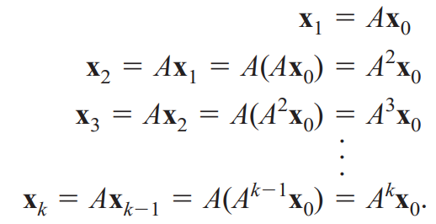

For large powers of k, and by properly scaling this sequence, we will see that we obtain a good approximation of the dominant eigenvector of A.

## Problem Statement:

# Generate the MATLAB Code to implement Power Method for any size of Matrix.

## MATLAB Code:

|  |
| --- |
| clear all, clc  %% Defining Variables and Matrix    %A = input("Matrix A\n");  %B = input("Matrix B\n");  % Program repetition when using input function    A = [1, 2; 3, 4]  B = [1; 0] %Eigen Vector    e = 1 * 10^-14;  eCalc = e/2;  NewB = B;  oldEigen = 0;  i = 0;    %% Code    for R = 1:10000  C = A*NewB;  Eigen = max(C);    NewB = C/Eigen;    eCalc = abs((Eigen - oldEigen)/(Eigen));  oldEigen = Eigen;    if eCalc < e  break  end    i = i + 1;  end    fprintf("Eigen Value: %.4f calculated in %.0f iterations\n", Eigen, i) |

## Results:

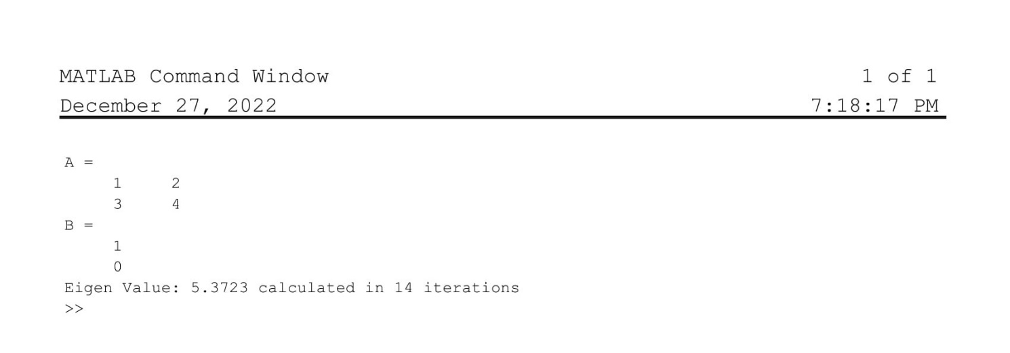

## Discussion

Comments will be made on the following

1. What are the restriction to choose the values for the initial guess?